COMSATS University Islamabad

Abbottabad campus

Semester Project

SUBJECT: **Object Oriented Software Engineering**

TEACHER: **Sir Jawad Khan**

CLASS: **BSE-4D**

STUDENT:

* **Muhammad Kashan <** FA20-BSE-008 **>**
* **Wajid Akbar <** FA20-BSE-014 **>**
* **Hozefa Rizvi <** FA20-BSE-019 **>**
* **Najeeb Said <** FA20-BSE-023 **>**
* **Asad Waseem <** FA20-BSE-153 **>**

Contents

1. Vision 3
   1. What is Inventory Management System? 3
   2. Why is Inventory Management System important? 3
   3. What are benefits of Inventory Management System? 4
   4. Scope 5
      1. Manage Inventory: 5
      2. Less Storage: 5
      3. Improve Productivity: 5
      4. Increase Profits: 5
   5. Functional & Non Functional Requirements 5
      1. Functional Requirements: 5
      2. Non-Functional Requirements: 5
2. Domain Model 6
   1. Domain Model real world classes: 6
3. Use Case Diagram 7
   1. Primary Actors in Inventory Management System: 7
   2. Fully Dressed Use Cases 7
      1. Use Case UC1: Generate Report 7
      2. Use Case UC2: Sales 9
   3. Brief Usecases: 10
      1. Use Case UC3: Login 10
      2. Use Case UC4: Create Membership 10
      3. Use Case UC5: Stock Purchase 10
      4. Use Case UC6: Check Available Stock 10
4. System Sequence Diagram 11
   1. SSD: UC ~ LOGIN: 11
   2. SSD: UC ~ PROCESS SALE: 11
5. Operation Contracts 12
   1. Operation Contract: LOGIN 12
   2. Operation Contract: PROCESS SALE: 12
6. Sequence Diagram 12
   1. Actors & Lifelines in Sequence Diagram: 13
      1. Actor 13
      2. Lifelines 13
7. Class Diagram 14
   1. Image Link: 14
8. User Interface 15
   1. Loading: 15
   2. Login: 16
   3. Mainpage: 17
      1. Add item: 17
      2. Process Sale: 17
      3. Create Member: 18
      4. Generate Reports: 18
      5. View All Items: 19
   4. Transaction Menu: 19

# Vision

## What is Inventory Management System?

Inventory management helps companies identify which and how much stock to order at what time. It tracks inventory from purchase to the sale of goods. The practice identifies and responds to trends to ensure there’s always enough stock to fulfil customer orders and proper warning of a shortage.

## Why is Inventory Management System important?

* Inventory management System increases your company/business profit
* Inventory Management System improves customer satisfaction
* Inventory Management System make it easy to run your business

## What are benefits of Inventory Management System?

* Avoids risk of human error
* Save your endless hours and ensures that you don’t make mistakes
* Improves supply chain operations
* Reduced cost

## Scope

Manage Inventory: Inventory management helps to manage the stock of the company. It provides pertinent details of the products to the purchasing department.

Less Storage: When the inventory management provides accurate information to management, they buy according to them, which helps the company store fewer products.

Improve Productivity: Inventory management helps improve the productivity of the machines and human resources. Employees are aware of stocks and the quantity that require to produce.

Increase Profits: Inventory management helps to improve the profits of the company. It helps provide accurate information about stocks, saving unnecessary expenses on stocks.

## Functional & Non Functional Requirements

### Functional Requirements:

The System aims at providing an efficient interface to the user for managing inventory, and it shall also provide the user with varied options for managing the inventory through various functions at hand. The design is such that the user does not have to update the inventory every time manually. The ingredient levels are continuously monitored based on their usage and are checked for the threshold levels in the inventory, and accordingly, the user is alerted about low levels of certain ingredients.

### Non-Functional Requirements:

* Usability
* Reliability
* Performance
* Legal to use

# Domain Model

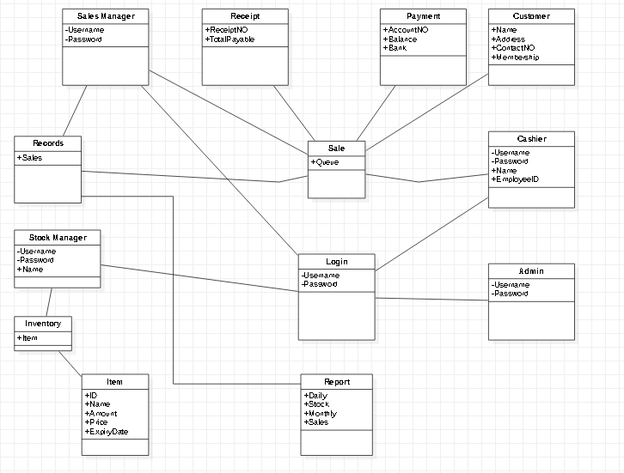

### Domain Model real world classes:

1. Sale
2. Sale Manager
3. Receipt
4. Payment
5. Customer
6. Cashier
7. Admin
8. Report
9. Login
10. Items
11. Inventory
12. Stock Manager
13. Records

# Use Case Diagram

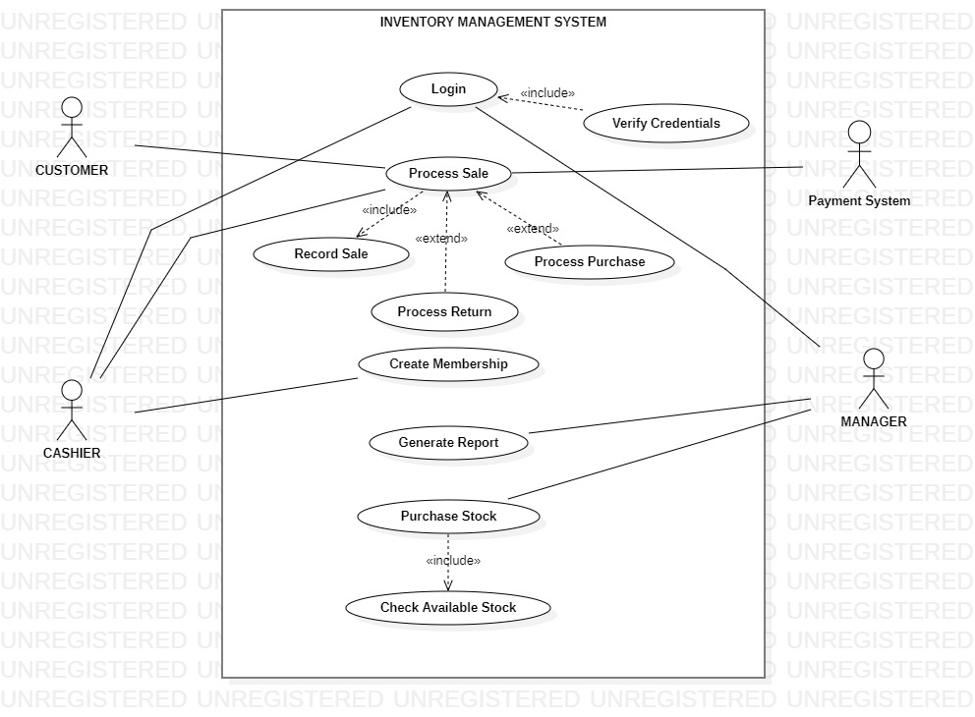

## Primary Actors in Inventory Management System:

* Customer
* Cashier
* Payment Systems
* Manager

## Fully Dressed Use Cases

### Use Case UC1: Generate Report

|  |
| --- |
| **Scope:** Inventory Management System |
| **Level:** User-goal |
| **Primary Actor:** Manager |
| **Stack Holders & Interests:**  **Manager:** Wants to know about the monthly Sales Report, most sold products, Returns completed, Number of visited customers, Most sales time. Wants to know about the available stock, out-of-stock items, incoming stocks, and Payments report. |
| **Pre-Condition:** Manager is successfully logged in. Database System is running. |
| **Post-Condition:** The requested report is generated and saved into a CSV file with full details. A printable PDF file is created. The final report is shown on the screen. |
| **Main Success Scenario:**   1. Manager login to the system. 2. Starts the Report process. 3. Enter the required information query. 4. The system displays the data on the screen and asks for confirmation. 5. After confirmation, the report is exported in PDF and CSV format. |
| **Extensions:**  If the data retrieval fails because of missing data or other database-related issues.   1. Manager starts backup and recovery process. 2. Recovers the data. 3. Restart the Report process. |
| **Special Requirements:**  The displayed report must be in a proper format. |
| **Technology and Data Variation List:**  Export file format must be CSV or PDF or both |
| **Frequency of Occurrence:** As requested by Manager. |

### Use Case UC2: Sales

|  |
| --- |
| **Scope:** Sales |
| **Level:** User-goal |
| **Primary Actor:** Cashier |
| **Stack Holders & Interests:**  **Cashier:** Wants easy product entry, faster bill generation, and stock updates.  **Customer:** Wants fast service with minimal effort, easily visible display of entered items and prices. Wants proof of purchase to support returns.  **Manager:** Wants the sale to be recorded with date, time, and complete details of Purchased items. Wants stock report to be updated and should be notified about nearly out-of-stock items.  **Payment System:** Wants to receive digital authorization requests in the correct format and protocol. |
| **Pre-Condition:** Cashier is successfully logged in. The System is up and running. |
| **Post-Condition:** The sale is recorded with date and time, inventory is updated, Receipt is generated, and Payment records are updated. |
| **Main Success Scenario:**   1. The cashier starts a new sale. 2. All items are entered into the System one by one until all are done. 3. The calculated total with taxes is shown to the customer and is asked for payment. 4. The customer chooses a payment method, and the Payment system handles the transaction. 5. The Receipt is generated. 6. The System records the sale, the payment record is saved, and inventory is updated. |
|  |
| **Extensions:**  The manager overrides the process.   1. Login to System as manager 2. Checks balance, cancel a sale, delete an item from system. 3. Restarts the system.   Customer wants to change payment method.   1. Payments System reverts to initial state. 2. Customer chooses payment method. 3. The sale process continues.   Customer wants to return an item.   1. Cashier asks for receipt. 2. Checks receipt in system. 3. If record is found, cashier proceeds with return process. 4. If record is not found, cashier declines return and ask for some other proof. |
| **Special Requirements:**  The payment process must take less than 30 seconds.  Items and calculated prices must be visible to the customer. |
| **Technology and Data Variation List:**  Item identifier must be done with a barcode scanner or manual input. |
| **Frequency of Occurrence:** Depending on customer arrival. |

## Brief Usecases:

### Use Case UC3: Login

Admin, Manager, or Cashier starts the system to do something. System asks for their username and password. If credentials are correct, then access is granted. Otherwise, access is denied, and he/she is asked for the credentials again until verification is successful.

### Use Case UC4: Create Membership

A customer arrives at the shop to purchase. The Cashier asks the customer if he/she wants to register as a member. If the customer agrees, the Cashier asks him to enter his details into the system. After successful registration, the Cashier gives the membership id to the customer.

### Use Case UC5: Stock Purchase

The manager logs into the system. He checks for out-of-stock items and most-sold-items report. Then he shortlists items that need to be purchased from the reports and purchases those items.

### Use Case UC6: Check Available Stock

A customer arrives to buy something and asks Cashier to check the availability of a certain item. The Cashier checks the item in the inventory and reports to the customer if an item is available or not.

# System Sequence Diagram

## SSD: UC ~ LOGIN:

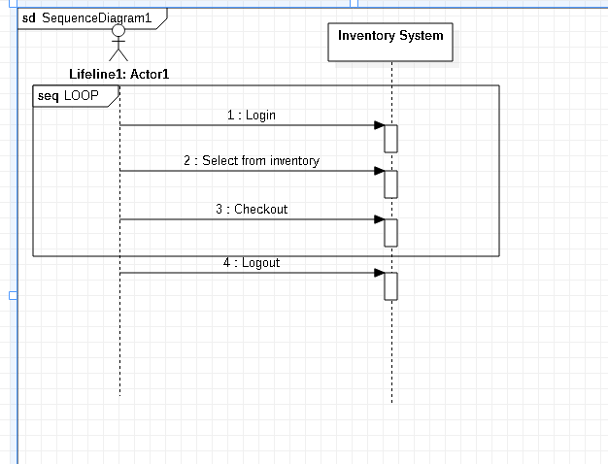

## SSD: UC ~ PROCESS SALE:

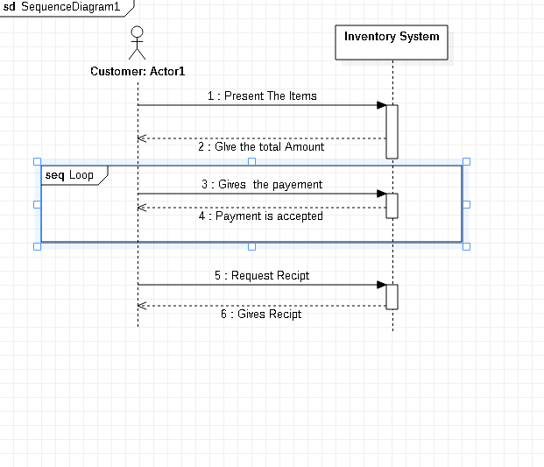

# Operation Contracts

## Operation Contract: LOGIN

* Operation: Login (int id, String name) •
* Cross references: use case Login
* Precondition: customers should enter name and id for Login •
* Post condition: Customer should select inventory and checkout.

## Operation Contract: PROCESS SALE:

* Operation: Process Sale(int payment, String Item)
* Cross references: use case Process Sale
* Precondition: Stock Manager should request to generate purchase order
* Post condition: Stock Manager will receive purchase order

# Sequence Diagram

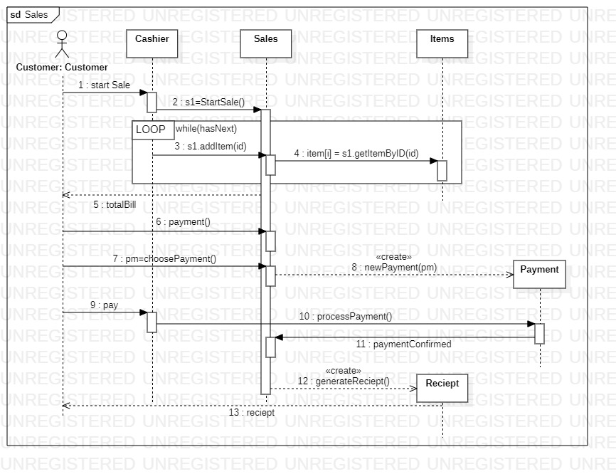

## Actors & Lifelines in Sequence Diagram:

### Actor

* Customer

### Lifelines

* Cashier
* Sales
* Items
* Payments
* Receipt

# Class Diagram

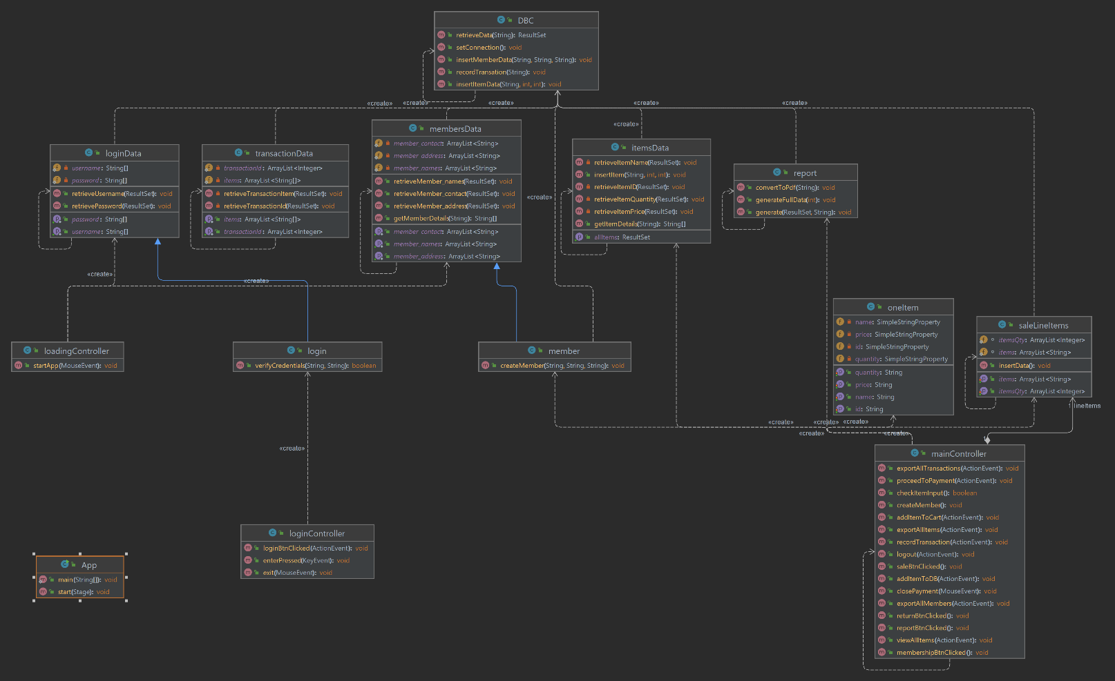

## Image Link:

Diagram above is not clear because of page size

# User Interface

## Loading:

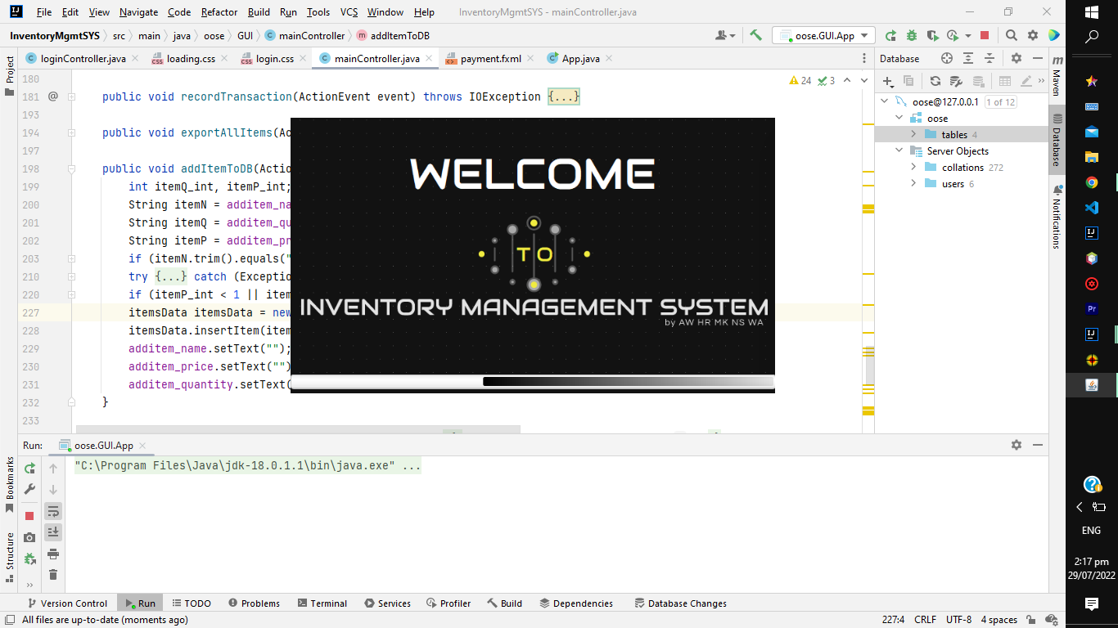

## Login:

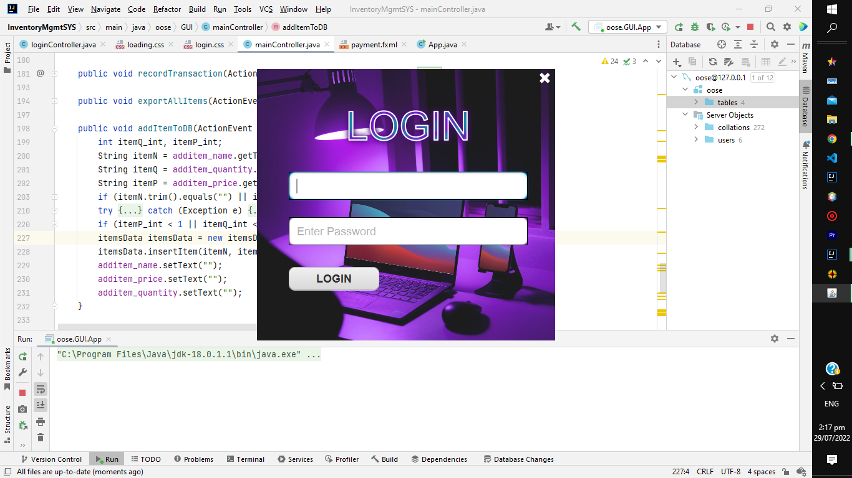

## Mainpage:

### Add item:

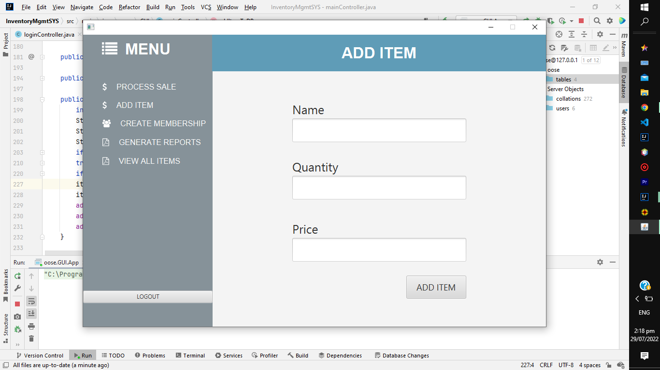

### Process Sale:

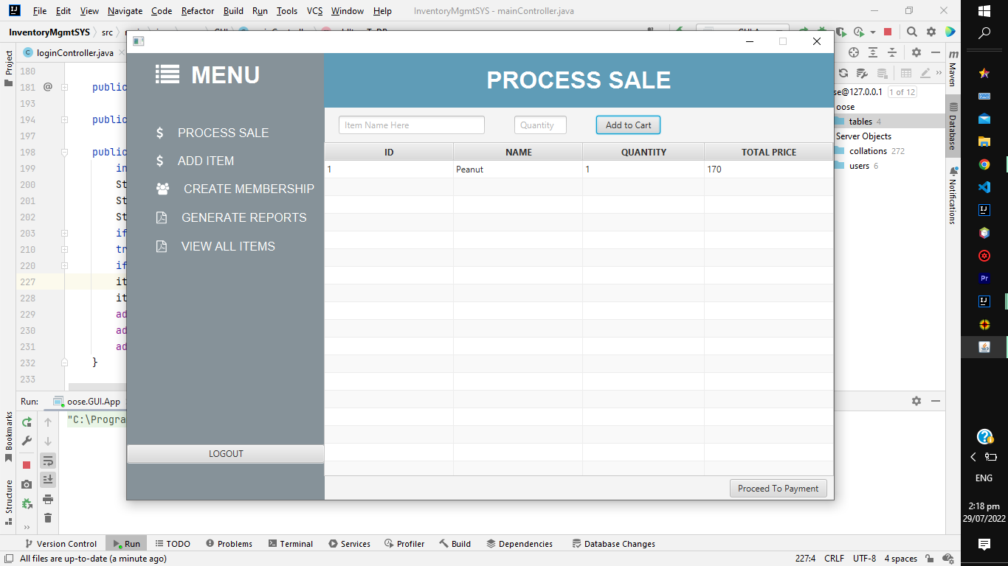

### Create Member:

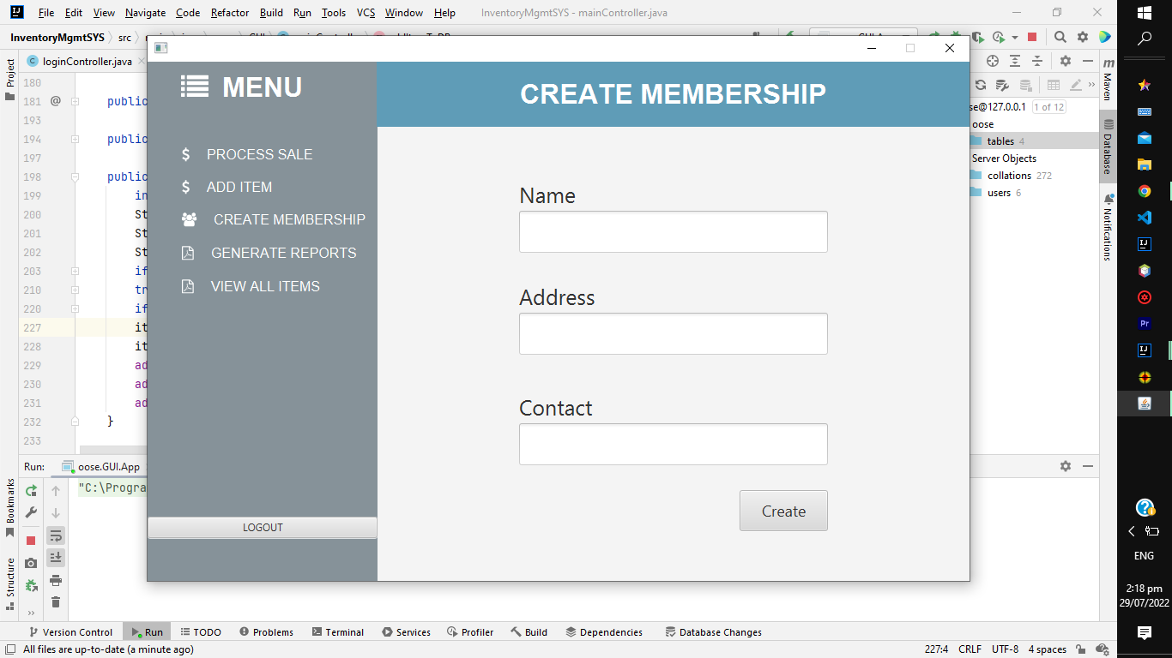

### Generate Reports:

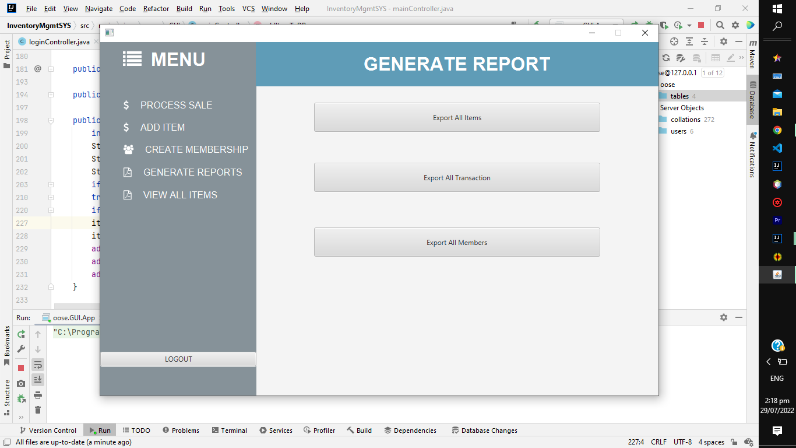

### View All Items:

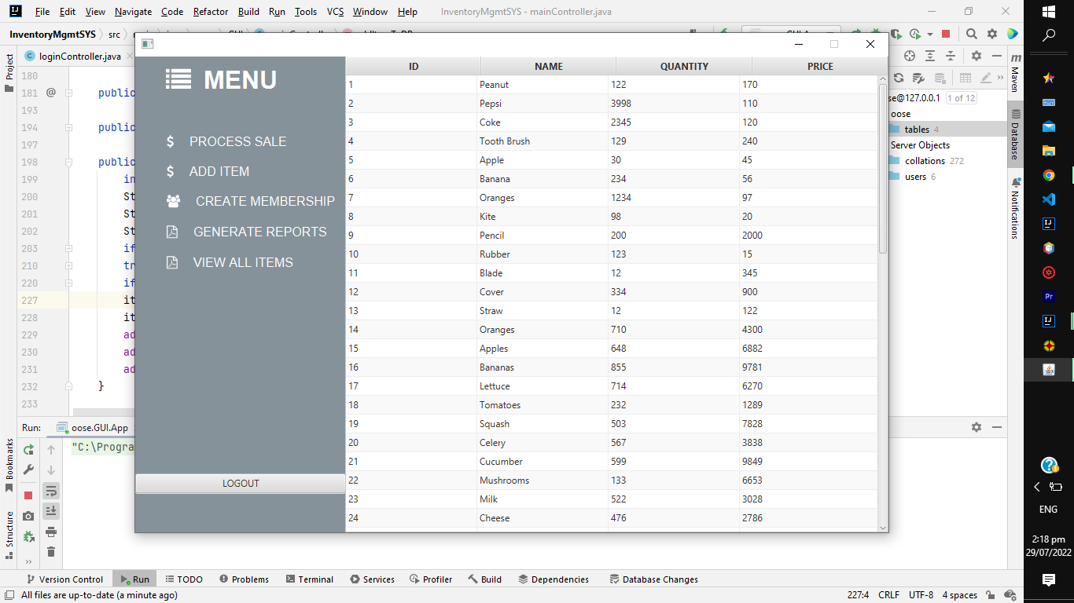

## Transaction Menu:

